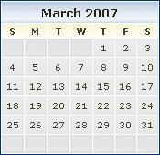
Spring breaks
Northwestern spring break: March 19-23
UIC spring break: March 26-30
IIT spring break: March 12-17
Depaul spring break: March 21-27
Loyola spring break: March 5-9
UC spring break: March 17-26
Notre Dame spring break: March 3-10

Holidays and other notable events
Easter holiday: April 6-8
Loyola classes end: April 27
Passover: April 3-10

Possible dates for symposium:

April 14
April 21

